**GUJARAT TECHNOLOGICAL UNIVERSITY**

**C. K. PITHAWALLA COLLEGE OF ENGINEERING AND TECHNOLOGY, SURAT (009)**

**CIVIL ENGINEERING DEPARTMENT**

**REPORT OF WEBINAR ORGANIZED**

**Academic Year 2020-21**

**Program was scheduled as per the given details**

* **Topic : Webinar on “Government Jobs”**
* **Date : 07/11/2020**
* **Day : Saturday**
* **Venue : Civil Engineering Department, CKPCET, Surat**
* **Student Class : CKPCET (All students)**
* **Student Attendance : Attendance Report attached**

* **Program Schedule :**

|  |  |  |
| --- | --- | --- |
| **Time** | **Event** | **Managed By** |
| **11:00 am to 12:45 pm** | **Webinar on “Government Jobs”** | **Dr. Boski P. Chauhan** |

* **Brief Report :**
* **Mr. Ashish Singh, Board of Director Examshala, Surat, has conducted webinar on ‘Government jobs’.**
* **The webinar was organized for all students of CKPCET to get guidance for building career in government sectors for young engineers.**
* **The webinar covered detailed information for eligibility criteria and paper pattern for GPSC class 1 & 2 exams.**
* **Paper pattern for various competitive exams was explained to the participants.**
* **Students were explained how to do planning and strategizing for the government exams.**
* **Students get encouraged for managing their time judiciously and stick to the action plan for clarify the exams.**
* **Many questions were asked by students in doubt clearing session at the end of the webinar.**
* **Total 48 students have attended the webinar.**

SNAPS

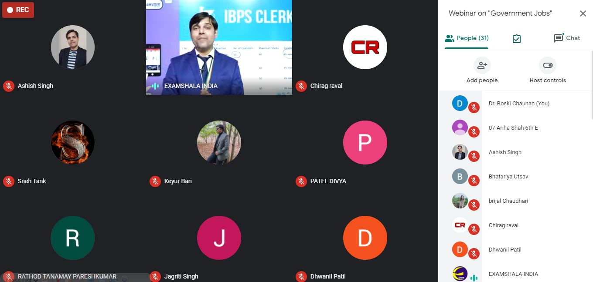 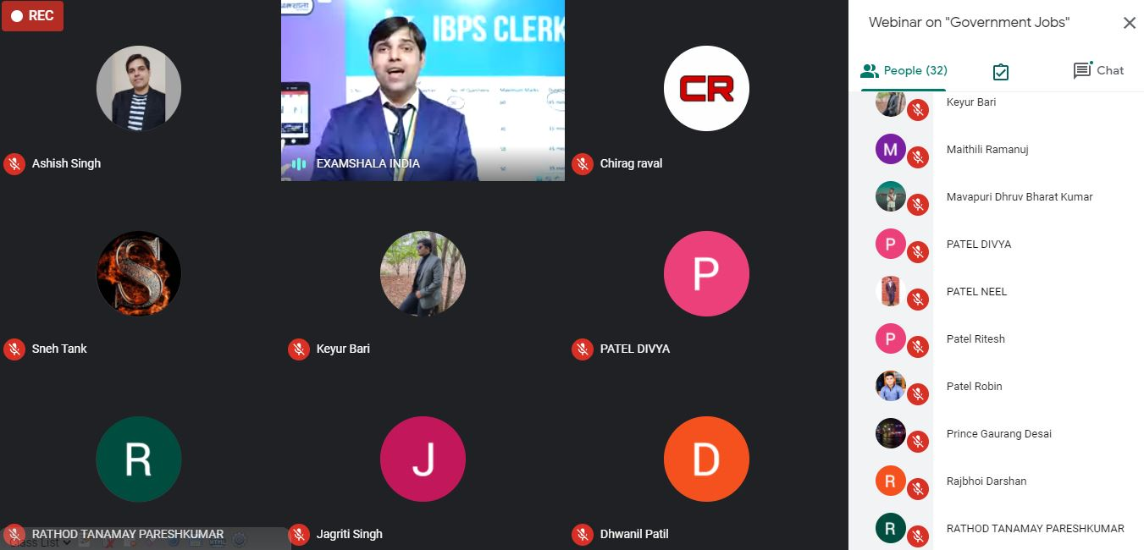

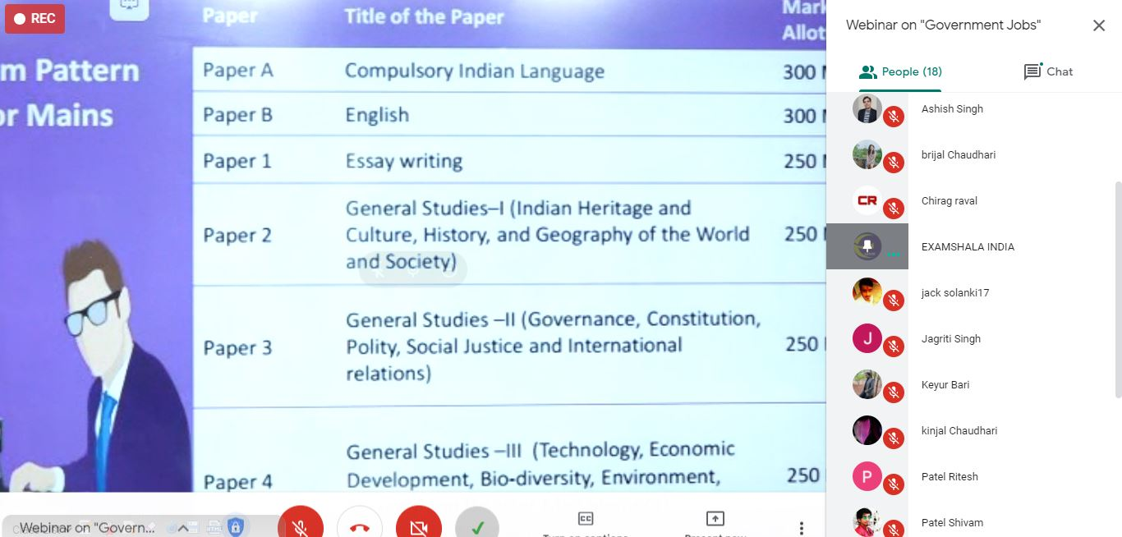

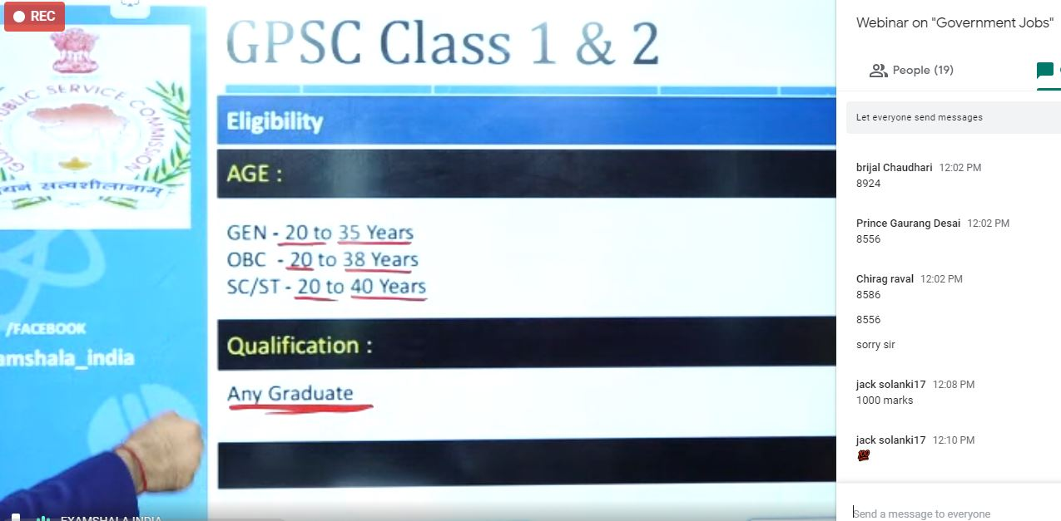

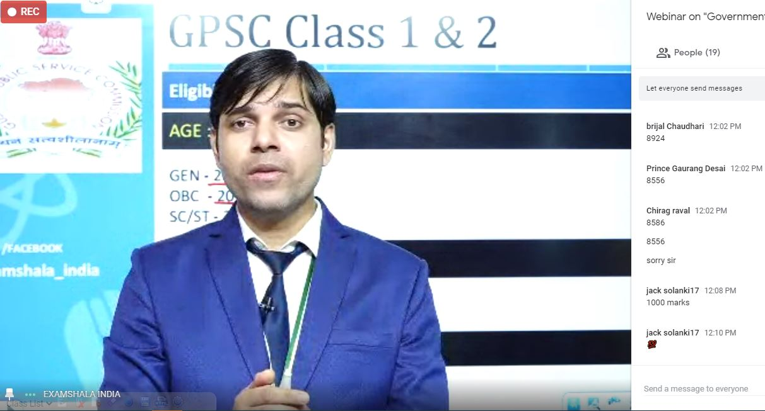

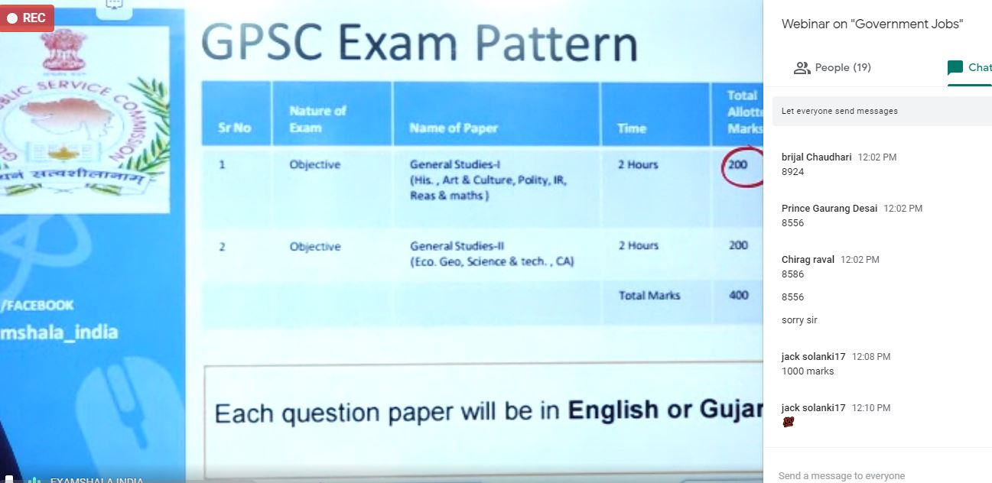

**LIST OF THE PARTICIPANTS**

|  |  |
| --- | --- |
|  | Kathiriya Akash |
|  | Ariha |
|  | Keyur Bari |
|  | Dinesh Chandwani |
|  | Dhrutee Chaudharee |
|  | Brijal Chaudhari |
|  | Kinjal Chaudhari |
|  | Rajbhoi Darshan |
|  | Rana Darshil |
|  | Vakhariya Deep |
|  | Pranav Desai |
|  | Prince Gaurang Desai |
|  | Patel Divya |
|  | Riya Doliya |
|  | Pinky Gupta |
|  | Garude Harshad |
|  | Examshala India |
|  | Umrigar Siddharth J |
|  | Shubham Kukreja |
|  | Mavapuri Dhruv Bharat Kumar |
|  | Chetan Lodhe |
|  | Sahil Mevawala |
|  | Umrigar Jaini Naineshbhai |
|  | Mistry Neel |
|  | Patel Neel |
|  | Rathod Tanamay Pareshkumar |
|  | Dipesh Patel |
|  | Jinal Patel |
|  | Vraj Patel |
|  | Dhwanil Patil |
|  | Maithili Ramanuj |
|  | Maurya Sachin Ramchandra |
|  | Om Rana |
|  | Chirag Raval |
|  | Patel Ritesh |
|  | Patel Robin |
|  | Ravaliya Shaheel |
|  | Ganesh Sharma |
|  | Patel Shivam |
|  | Patel Shrey |
|  | Ashish Singh |
|  | Jagriti Singh |
|  | Jack Solanki17 |
|  | Sneh Tank |
|  | Harendra Singh Tomar |
|  | Bhatariya Utsav |
|  | Naik Vedant |
|  | Kantharia Vrushti |