**GUJARAT TECHNOLOGICAL UNIVERSITY**

**C. K. PITHAWALLA COLLEGE OF ENGINEERING AND TEC “Trending Career in Facilities Management”HNOLOGY, SURAT (009)**

**CIVIL ENGINEERING DEPARTMENT**

**REPORT OF WEBINAR ORGANIZED**

**Academic Year 2020-21**

**Program was scheduled as per the given details**

* **Topic : Webinar on**
* **Date : 03/10/2020**
* **Day : Saturday**
* **Venue : Civil Engineering Department, CKPCET, Surat**
* **Student Class : BE II, III, IV**
* **Student Attendance : Attendance Report attached**

* **Program Schedule :**

| **Time** | **Event** | **Managed By** |
| --- | --- | --- |
| **06:00 pm to 07:00 pm** | **Webinar on “Trending Career in Facilities Management”** | **Dr. Boski P. Chauhan, Assistant professor, CED, CKPCET** |

* **Brief Report :**
* Following topics were covered in the webinar  
    
  - Why are careers in Facility Management trending?  
  - Current Opportunities and job market in this field!  
  - How diverse engineering fields contribute to this career?  
  - Facility Management degree programs in Canada and US (Masters)  
  - A day in the Life of a Facility Manager!
* The webinar on 'Trending Career in Facilities Management' was organized by  Boarding Pass For Success, in association with 6 colleges and universities.
* **The speakers were:**

Ruchika Shah, Founder of Facilities Guru, Canada

Case Runolfson, Sr  Director, Facilities Management, AIR, 2nd Vice Chair, IFMA Foundation Board, USA

* **Moderator**: Khushboo Vaidya, Founder of Boarding Pass For Success, Canada
* The speakers gave students valuable insights into the facilities management industry, the opportunities, use of IOT, sustainability and other technologies with facilities, masters degrees in this field around the world, title and salaries,  resources of IFMA for students to get started on this career and much more.
* A total of 279 attendees participated in webinar. Students asked many insightful questions and the speakers provided effective suggestions.

**Webinar Poster**

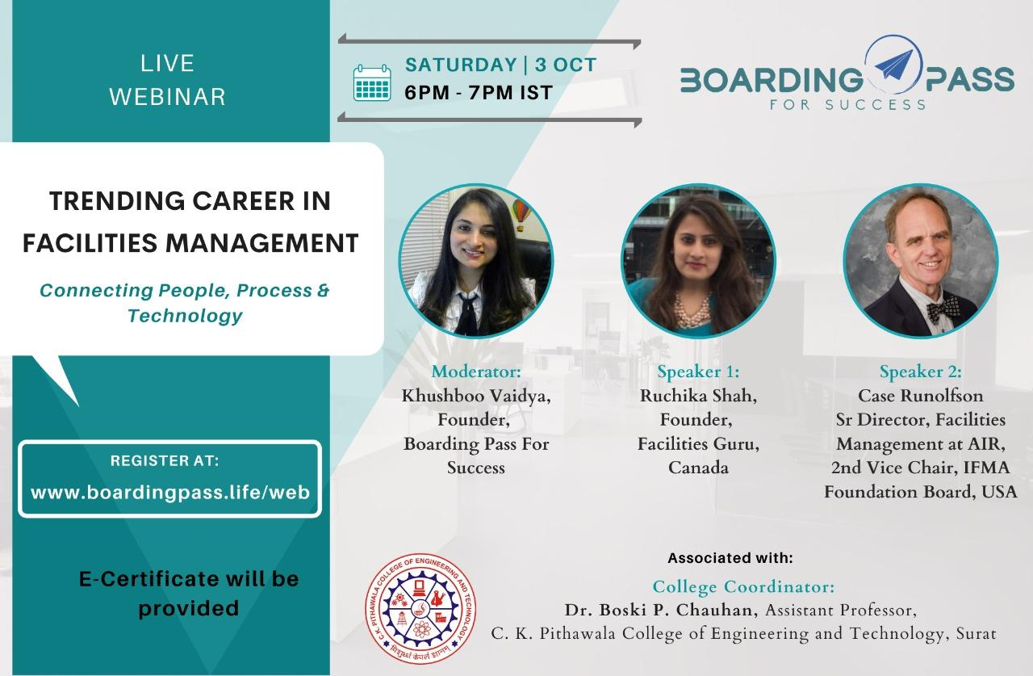

**SNAPS**

