**GUJARAT TECHNOLOGICAL UNIVERSITY**

**C. K. PITHAWALLA COLLEGE OF ENGINEERING AND TECHNOLOGY, SURAT (009)**

**CIVIL ENGINEERING DEPARTMENT**

**REPORT OF WEBINAR ORGANIZED**

**Academic Year 2020-21**

**Program was scheduled as per the given details**

* **Topic : Webinar on “Indian Government exams and opportunities ”**
* **Date : 20/12/2020**
* **Day : Sunday**
* **Venue : CKPCET, Surat**
* **Student Class : BE II, III, IV (All branches)**
* **Student Attendance : Attendance Report attached**

* **Program Schedule :**

|  |  |  |
| --- | --- | --- |
| **Time** | **Event** | **Managed By** |
| **06:00pm to 07:30 pm** | **Webinar on “Indian Government exams and opportunities ”** | **Dr. Boski P. Chauhan, Assistant professor, CED, CKPCET** |

* **Brief Report :**
* Topics Covered:
* UPSC, SSC, Defense Exams
* Exam Preparation
* Government Job Roles with these exams
* How you can contribute to the society!
* Q&A with the experts

The webinar on 'Indian Government Exams and Opportunities' organized by [Boarding Pass For Success](https://www.boardingpass.life/), was successfully conducted on 20th December 2020 in association with [STEM Educators' Consortium](https://www.boardingpass.life/consortium) and its member institutes.

**Out of 1457 registrations from students all over India, 25 students were from C. K. Pithawala College of Engineering and Technology, Surat.**

**Highlights from the Webinar:**

Students were provided insights into the different government exams like Union Public Service Commission, Staff Selection Commission, and Defense Exams. The speakers inspired students with various Govt roles with which they can contribute to society, the salary and benefits, time to prepare for each exam, the interview process and many such useful suggestions. We received great feedback from all the attendees.

**Speaker 1:**  
Mr. Tufel Noorani,  
Chief Mentor & Lecturer  
Archer IAS academy, Ahmedabad  
  
**Speaker 2:**  
Mr Naveen Jain,  
Inspector, Central Excise & Customs,   
Surat  
  
**Speaker 3:**  
Mr. Keval Acharya,  
Founder & Director,  
I.M.A Defense Academy, Ahmedabad  
  
**Moderator:**  
Khushboo Vaidya,  
Founder,   
Boarding Pass For Success, Canada, India

Webinar Poster

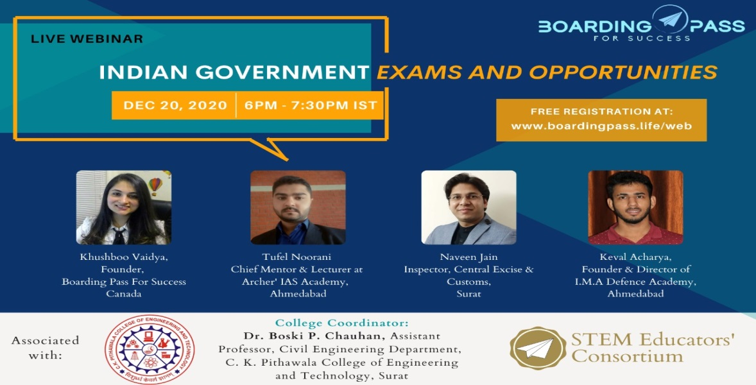

SNAPS

