**GUJARAT TECHNOLOGICAL UNIVERSITY**

**C. K. PITHAWALLA COLLEGE OF ENGINEERING AND TECHNOLOGY, SURAT (009)**

**CIVIL ENGINEERING DEPARTMENT**

**REPORT OF WEBINAR ORGANIZED**

**Academic Year 2020-21**

**Program was scheduled as per the given details**

* **Topic : Webinar on “Q & A with Sujen Shah (Data Scientist at Nasa**

**jet Propulsion Laboratory USA) ”**

* **Date : 23/1/2021**
* **Day : Saturday**
* **Venue : CKPCET, Surat**
* **Student Class : BE II, III, IV (All branches)**
* **Student Attendance :**

* **Program Schedule :**

|  |  |  |
| --- | --- | --- |
| **Time** | **Event** | **Managed By** |
| **10:00am to 11:00 am** | **Webinar on “Q & A with Sujen Shah (Data Scientist at Nasa jet Propulsion Laboratory USA) ”** | **Dr. Boski P. Chauhan, Assistant professor, CED, CKPCET** |

* **Brief Report :**
* Topics Covered:

- His Career Journey

- Data Science field

- Real world impact of its applications

- Important skills and how to get started

- Q&A Session

The webinar on“Q & A with Sujen Shah (Data Scientist at Nasa jet Propulsion Laboratory USA) ” organized by [Boarding Pass For Success](https://www.boardingpass.life/), was successfully conducted on 23rd January 2021 in association with [STEM Educators' Consortium](https://www.boardingpass.life/consortium) and its member institutes.

**Highlights from the Webinar:**

The speaker, Sujen Shah, shared his career journey, what initiatives he took during bachelors and what made him choose Data Science. Students got to know about the real-world applications of Data Science and how it is creating an impact in various sectors like space exploration, real time crop updates, geo informatics, and much more. He talked about the open source projects he worked on at NASA JPL and answered questions from the students. We received great feedback from all the attendees.

Speaker:

Sujen Shah,

Data Scientist, NASA JPL, USA

Moderator:

Khushboo Vaidya,

Founder,

Boarding Pass For Success, Canada, India

Webinar Poster

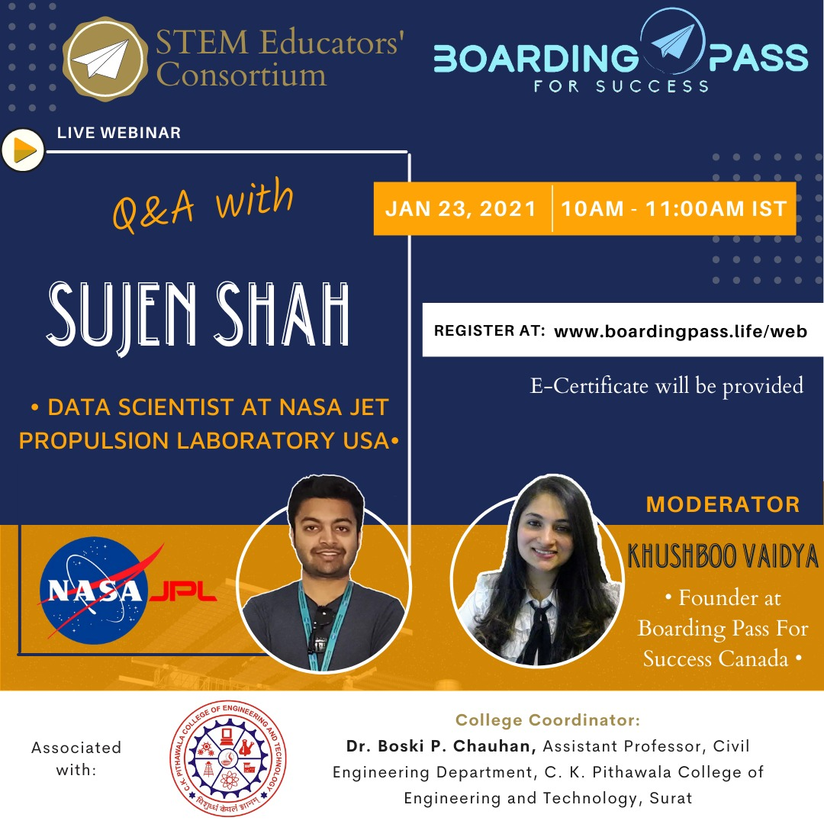

SNAPS

