**GUJARAT TECHNOLOGICAL UNIVERSITY**

**C. K. PITHAWALLA COLLEGE OF ENGINEERING AND TECHNOLOGY, SURAT (009)**

**CIVIL ENGINEERING DEPARTMENT**

**REPORT OF WEBINAR ORGANIZED**

**Academic Year 2020-21**

**Program was scheduled as per the given details**

* **Topic : Webinar on “Q & A with Maitrik Patel (Senior UI Engineer,**

**Apple, USA)”**

* **Date : 27/2/2021**
* **Day : Saturday**
* **Venue : CKPCET, Surat**
* **Student Class : BE II, III, IV (All branches)**
* **Student Attendance :**

* **Program Schedule :**

|  |  |  |
| --- | --- | --- |
| **Time** | **Event** | **Managed By** |
| **10:00am to 11:00 am** | **Webinar on Q & A with Maitrik Patel (Senior UI Engineer, Apple, USA)** | **Dr. Boski P. Chauhan, Assistant professor, CED, CKPCET** |

* **Brief Report :**
* Topics Covered:

-His career journey

- UI/UX Field

- Design and Development Tips for Industry

- Important skills and how to get started

**Highlights from the Webinar:**

The speaker, Maitrik Patel, shared his career journey, what initiatives he took during bachelors and shared valuable resources on developing UI/UX skills. Students got to know about the importance of good design using 3 case studies, how design plays an important role in development of web and mobile applications, different job roles and opportunities in the industry. He answered questions from the students and received great feedback from all the attendees.

Speaker:

Maitrik Patel,

Senior UI Engineer, Apple, USA

Moderator:

Khushboo Vaidya,

Founder,

Boarding Pass for Success, Canada, India

Webinar Poster

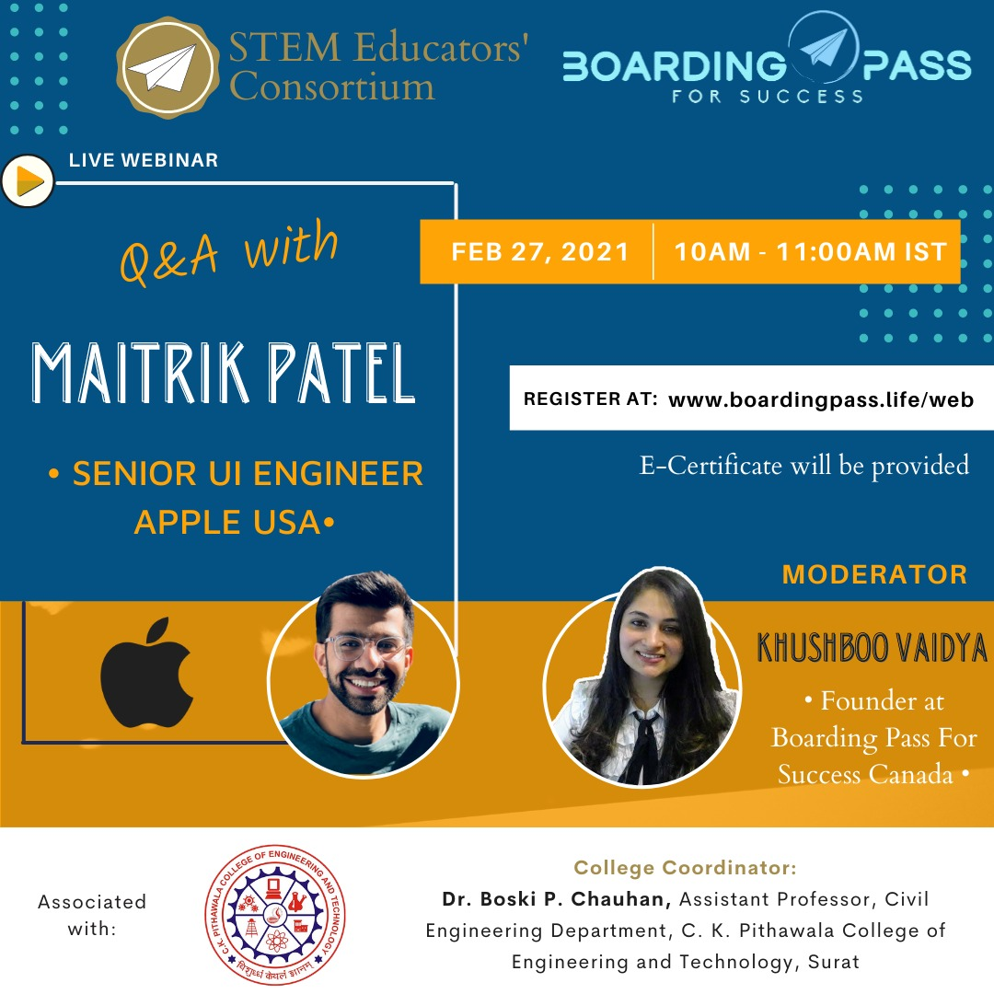

SNAPS

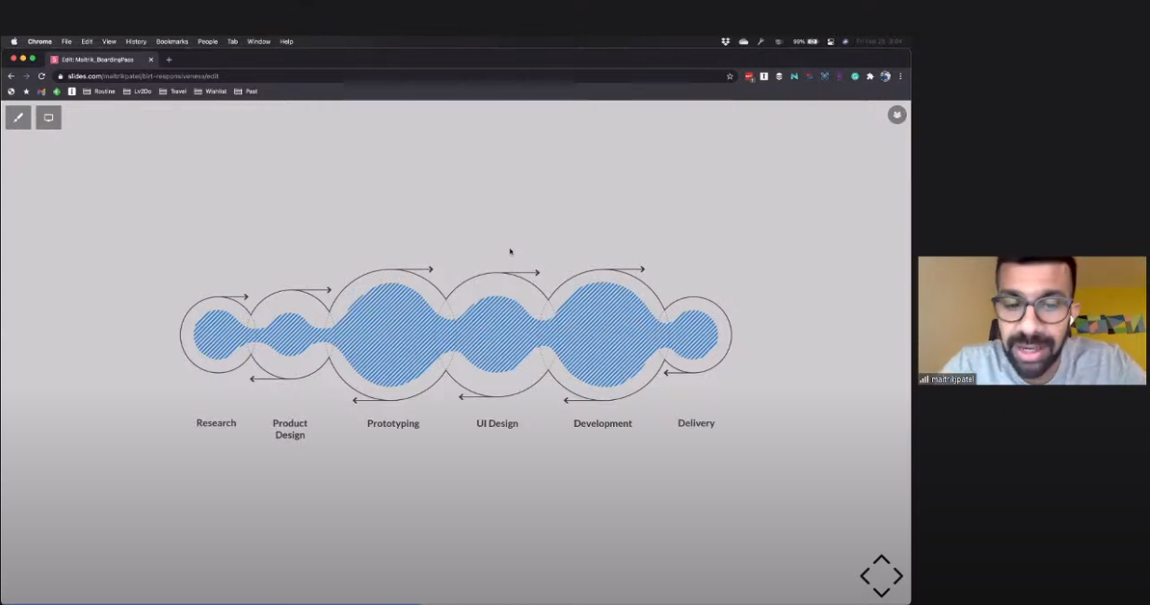

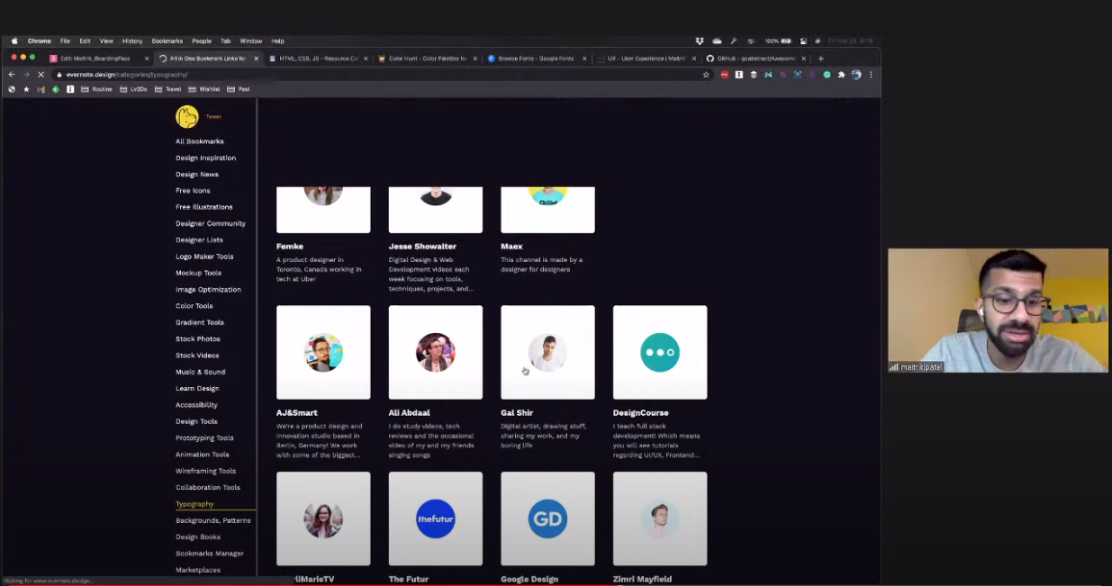

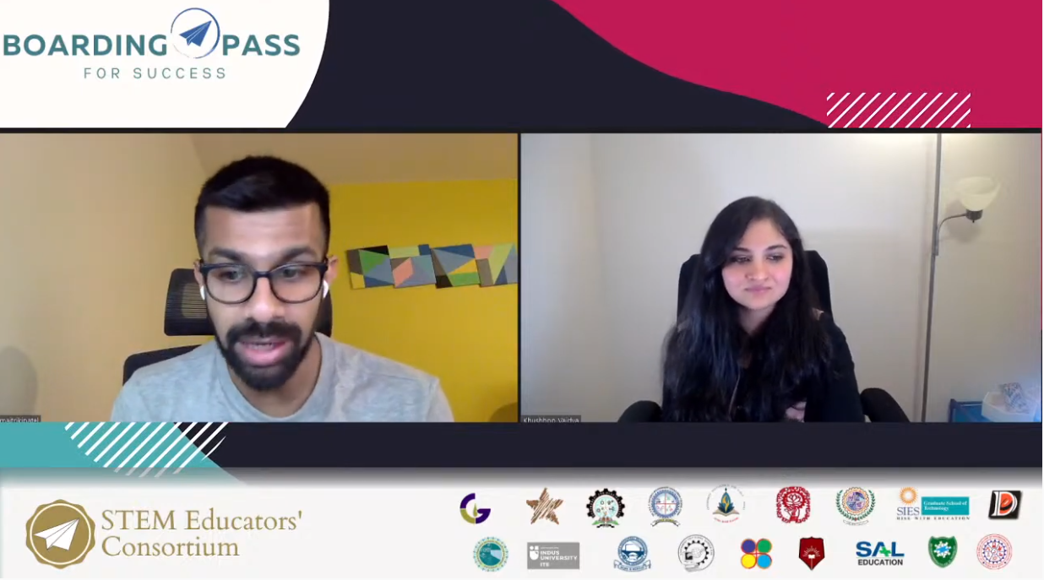

|  |  |  |
| --- | --- | --- |
| **First Name** | **Last Name** | **Email** |
| Neel | Mistry | neeelmistry1234@gmail.com |
| Kaushal | Khalasi | kaushalkhalasi44@gmail.com |
| Ishwar | Madekar | madekarishwar007@gmail.com |
| Vaiwala | Akshay | akvaiwala@yahoo.com |
| Viral | Chevli | rikichevli32@gmail.com |
| Sachin | Maurya | smourya250@Gmail.com |
| Keval | Patel | kevalpatel2114@gmail.com |
| Deep | Patel | deepp4008@gmail.com |
| Shrey | Chauhan | shreychauhan173@gmail.com |
| Patel | Tejas | pateltejas9302@gmail.com |
| Preet | Patel | Preetpatel12389@gmail.com |
| Riddhesh | Vadher | riddheshvadher9@gmail.com |
| vyoma | kotak | vyomakotak@gmail.com |
| Patel | Nikunj | nikunjpatel7351@gmail.com |
| JINAL | PATEL | jinalpatel14199@gmail.com |