Report on Webinar series (Part 1)
“Legal Aspects of Start-up”
(Online Mode)

Organized By: Applied Science and Humanities Department

Date: 28th August, 2021
Venue: ASH Dept., CKPCET, Surat
Mode: Online

Patron: Dr. Anish Gandhi, Principal, CKPCET, Surat
Dr. Pratik Shah, HOD-ASHD, CKPCET, Surat
Dr. Digvijay Kulshreshtha, Dean Research, CKPCET, Surat

Coordinators: Chandni A. Tiwari,
Ad-hoc Assistant Professor, ASH Department, CKPCET, Surat. Krupali S. Parekh,
Ad-hoc Assistant Professor, ASH Department, CKPCET, Surat.

A Webinar series (Part 3) “Legal Aspects of Start-up” was conducted by the Applied Science and Humanities Department of CKPCET in Collaboration with “S4 Extension Center” (S4: Student start-up support system) on 28th August, 2021.
The session was held by CA Mehul Shah, Head, Taxation Division, RASESH SHAH & Co, Surat. He has more than 9 years of experience as legal counsel for tax payer before the ITAT. He is also a founder at iKoVerk, Surat’ largest co-working space and has been hand holding innovative start-ups.
The webinar initiated with different types of business entities, NGOs, public and private limited companies, and start-up ecosystem. His talk was focussed on various stages and location importance, both in terms of real and virtual, as a system to create and scale new start-up companies. The main outcome stem from the explanation of facing failures, as majority of start-ups fail in the initial period.

Total 141 participants from different colleges/organizations of India have participated in this program and many faculties from the campus had attended this session.

The webinar series part 3 that was scheduled on 28th August 2021 at 4:00 p.m. through online mode initiated with the support of honourable trustees Shri Birenbhai Pithawala and Shri Rahulbhai Pithawala, Principal sir Dr. Anish Gandhi and in presence of Head of Department (ASHD) Dr. Pratik Shah as well as Dean Research Dr. Digvijay Kulshreshtha and the participants.

The session of this Webinar was too immersive and synergistic. Coordinators have received quality feedback from the participants as well as from speaker.

Glimpse, of this Webinar are shown below:
- Flyer of the webinar
- Few photograph’s

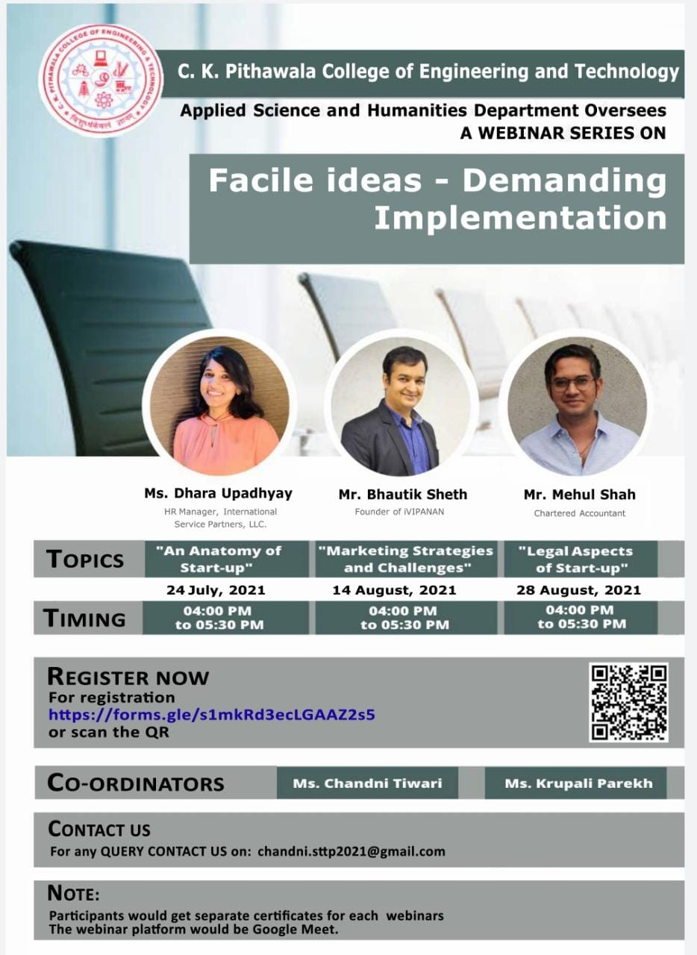
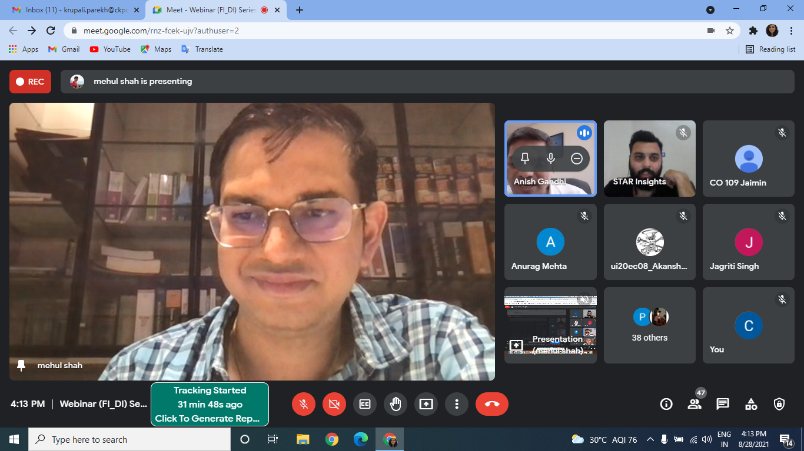
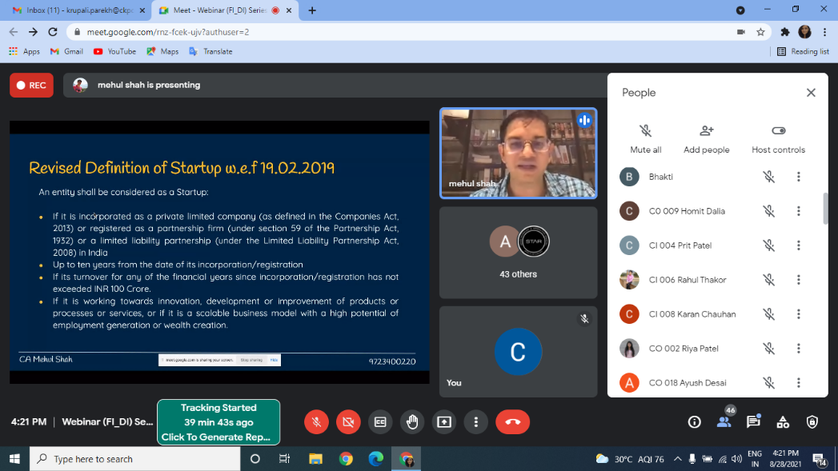
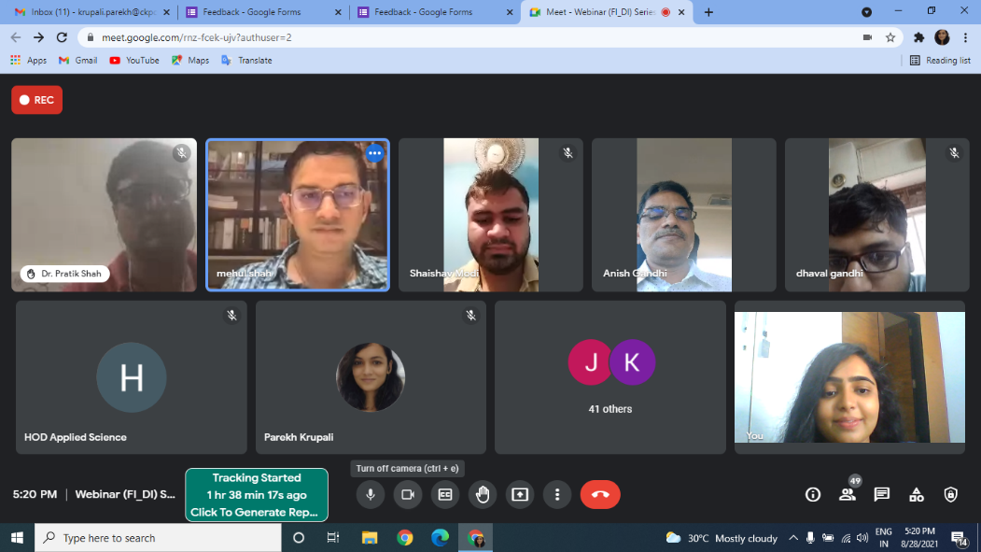
Coordinators: Chandni A. Tiwari
Krupali S. Parekh

